Chad Carmickle Module 12 4/19/19

Screen Resolution: 1080 x 1920

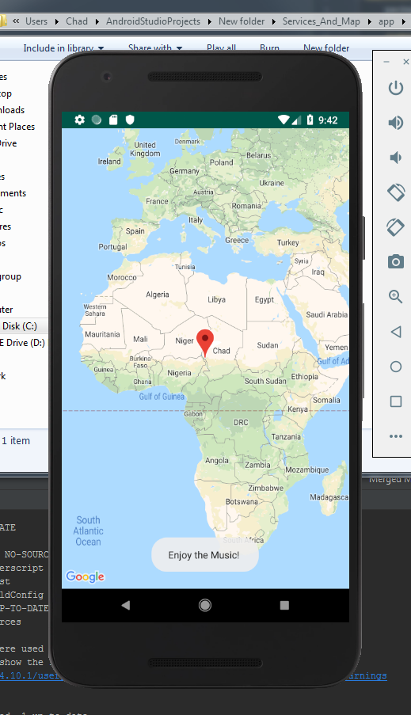The app was a little annoying trying to figure out what permissions and decencies I needed. After some digging I found the correct ones I required and placed them into the app. After reviewing the notes from class and looking at examples online I was able to recreate the project. I added in the location of Lake chad, since its me. After I added in the code for that I looked around for a service to use. I ended up using a music service I had used before but just played some elevator music in the background for the user.